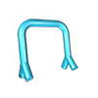

[VIRTUAL ROBOT](https://virtualrobot.net) releases new MIDI Effects: ECHO and CHORD

26 June 2020

VIRTUAL ROBOT today announced the immediate availability of new MIDI effects ECHO and CHORD.

VIRTUAL ROBOT’s MIDI effects are seriously easy to use and provide musical benefits to beginning producers as well as professionals. The controls are easily accessible through the clearly laid out user interface.

VIRTUAL ROBOT's latest MIDI effects are standalone applications for Windows. These MIDI effects can use MIDI virtual ports to connect to your DAW and behave like a plugin. They can also be used between your MIDI keyboard and a standalone software (or hardware) synthesizer so an expensive DAW is not required.

Both effect applications are fully configurable for MIDI CC (Continuous Control) streams. Each control can also do “MIDI learn”.

MIDI ECHO will echo an incoming MIDI note with variable delay time, number of echoes and velocity decay. MIDI ECHO also has variable internal MIDI clock or can synchronize to an external MIDI clock.

See the ECHO controls below:

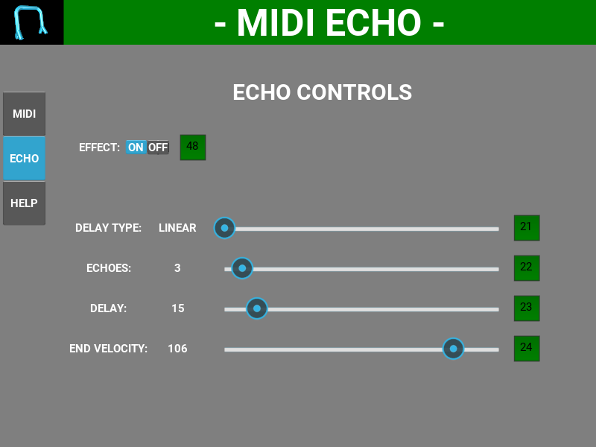

VIRTUAL ROBOT’s MIDI ECHO and MIDI CHORD are powerful tools for those who like to get creative and want to develop their own signature sound.

**Availability & Pricing**

MIDI ECHO and MIDI CHORD are available from the VIRTUAL ROBOT Online Shop. The suggested retail price for either download is $25 USD.

Read more at

<https://www.virtualrobot.net>